BUSINESS REQUIREMENTS DOCUMENT
Enterprise Healthcare Data Platform (EHDP)
UC2 - Enterprise Data Engineering Capstone Project
Document field | Details
Project methodology | Agile Scrum
Project duration | 3 months
Primary data source | Synthea Synthetic Healthcare Dataset
Technology stack | Pentaho, PostgreSQL, Python/Pandas, Power BI and Git
Document version | 1.0
Document status | Draft for review
Prepared date | 21 August 2026

Prepared by
Smrithi Rajan | Febi Sarju | Harish G

Document Control
Version | Date | Prepared by | Change description | Status
1.0 | 21-Aug-2026 | UC2 project team | Initial BRD prepared from approved project inputs | Draft

Approval Matrix
Role | Name | Decision | Date / Signature
Data Engineering Lead | ________________ | Pending | ________________
Project Guide | ________________ | Pending | ________________
Business Representative | ________________ | Pending | ________________

Document Purpose
This Business Requirements Document defines the business need, scope, stakeholders, data expectations, functional requirements, quality rules, reporting needs, acceptance criteria and traceability expectations for the Enterprise Healthcare Data Platform. It is the baseline against which the project deliverables will be reviewed.
Important distinction: The Project Charter authorizes and frames the project. This BRD specifies what the solution must accomplish and how completion will be verified.

1. Executive Summary
ABC Healthcare Group operates a network of 12 multi-specialty hospitals and 35 diagnostic centres across India. Clinical and operational information is generated by hospital, electronic health record, laboratory, pharmacy, billing, insurance, radiology, ICU and appointment systems. Because these sources are fragmented, decision-makers do not have a consistent enterprise view of patient flow, resource utilization, clinical activity and financial operations.
The EHDP project will establish a governed data pipeline using Synthea synthetic healthcare data as the implementation source. Data will be ingested through Pentaho, validated and standardized, stored in PostgreSQL and prepared for Power BI analytics. Metadata, audit logging, lineage, source-to-target mapping and Git-based version control are treated as required controls rather than optional documentation.

2. Business Background and Problem

2.1 Current Business Situation
Healthcare information is produced by multiple systems with different formats, structures and levels of completeness. In the current state, data must be manually interpreted and combined before it can support operational or executive reporting.

2.2 Problem Statement
The absence of an integrated and reliable data foundation makes it difficult to monitor patient journeys, compare hospital operations, analyse clinical outcomes, understand billing and insurance activity, and provide consistent management information.

2.3 Business Impact
- Hospital administrators cannot consistently monitor patient flow and resource utilization across facilities.
- Doctors and analysts lack a reliable integrated view of clinical events.
- Finance and operations teams must reconcile information from separate sources.
- Management reporting is delayed by repeated manual preparation and inconsistent definitions.
- Data errors are difficult to trace when metadata, audit records and lineage are incomplete.

3. Business Objectives and Outcomes
- Integrate selected healthcare datasets into one governed platform.
- Standardize patient, encounter, clinical and operational data.
- Create trusted PostgreSQL datasets for analysis and reporting.
- Make data-quality failures visible and traceable.
- Maintain metadata, audit records, lineage and source-to-target mappings.
- Support reproducible collaboration through Git and GitHub.
- Prepare curated outputs for Power BI operational and executive dashboards.
Expected outcome: A repeatable end-to-end healthcare data pipeline that converts fragmented source files into validated, documented and analytics-ready datasets.

4. Stakeholders
Stakeholder | Business interest | Primary responsibility
Doctors | Reliable patient and clinical information | Review the usefulness and interpretation of clinical data
Hospital administrators | Patient flow and hospital operations | Define operational reporting needs
Finance team | Billing, claims and cost information | Validate financial measures and reconciliation needs
Operations team | Resource utilization and efficiency | Define operational KPIs and exceptions
Management | Executive-level analytics | Approve business outcomes and reporting priorities
Data engineering team | Reliable and maintainable platform | Develop, test and document pipelines
Data Engineering Lead | Technical governance and quality | Guide design decisions and approve deliverables

5. Current-State and Future-State Processes

5.1 Current State (As-Is)
- Healthcare data is generated in separate clinical and operational systems.
- Files and records use different structures, formats and business definitions.
- Data is manually cleaned and consolidated for individual reporting needs.
- Reports may contain inconsistent counts, definitions or missing information.
- Errors are difficult to trace back to a specific source record or pipeline run.

5.2 Future State (To-Be)
- Synthea CSV and JSON datasets are collected into a controlled landing area.
- Pentaho pipelines ingest source data into PostgreSQL Bronze or staging tables.
- Validation and standardization rules create trusted Silver datasets.
- Curated Gold-layer datasets support reporting and analytics.
- Audit logs, metadata, lineage and mappings provide end-to-end traceability.

6. Scope
In Scope | Out of Scope / Later Phase
Synthea dataset analysis and integration | Use of real patient-identifiable information
CSV and JSON ingestion through Pentaho | Direct production integration with hospital systems
PostgreSQL staging, Bronze, Silver and Gold structures | Continuous real-time ICU waveform processing
Data validation, standardization and exception handling | Complete diagnostic images and radiology narrative reports
Metadata, audit logging, lineage and source-to-target mapping | Enterprise production deployment and high-availability infrastructure
Power BI-ready trusted datasets | Advanced predictive modelling unless separately approved
Git/GitHub version control and technical documentation | Unapproved third-party datasets

Scope control: Appointment scheduling, ICU device logs and complete radiology reports are not fully represented by the current Synthea files. They must be recorded as explicit gaps rather than treated as available data.

7. Business Requirements
Requirements are expressed as measurable capabilities. Technology names are included only where the project charter makes them mandatory constraints.
ID | Business requirement | Priority | Acceptance criterion
BR-01 | The platform shall ingest the approved Synthea CSV and JSON datasets. | High | Every approved source file is processed and a run result is recorded.
BR-02 | The platform shall maintain a unified patient identifier across related healthcare records. | High | Patient-linked records resolve to an existing patient or are rejected with a reason.
BR-03 | The platform shall link encounters to patients and applicable clinical or operational records. | High | Encounter relationships pass documented referential-integrity checks.
BR-04 | The platform shall validate mandatory fields, formats, dates, identifiers and business rules. | High | Validation results are available for each processed dataset.
BR-05 | Invalid records shall be separated from valid records and logged with an error reason. | High | Rejected rows can be traced to source file, record and validation rule.
BR-06 | Validated source data shall be stored in PostgreSQL staging or Bronze tables. | High | Target tables are populated and source-to-target counts are reconciled.
BR-07 | The platform shall support controlled cleansing and standardization into Silver datasets. | High | Approved transformation rules produce consistent formats and values.
BR-08 | Curated Gold datasets shall be available for Power BI reporting. | High | Approved reporting datasets can be queried and contain documented business definitions.

ID | Business requirement | Priority | Acceptance criterion
BR-09 | Every ETL run shall maintain audit information. | High | Run ID, start/end time, status, input count, output count and reject count are captured.
BR-10 | Metadata, lineage and source-to-target mappings shall be maintained. | High | A reviewer can trace an analytical field back to its source and transformation.
BR-11 | Pipeline reruns shall not create unintended duplicate records. | High | Reprocessing the same controlled input preserves the expected unique record counts.
BR-12 | Code, SQL, ETL assets, tests and documentation shall be version-controlled. | Medium | Approved artifacts are committed to Git with meaningful history.

8. Data Source Requirements and Coverage
Synthea is the approved synthetic source. The mapping below distinguishes directly covered domains from partial, derived and missing operational content.
Business use case | Best available Synthea source(s) | Coverage
Patient registration | patients.csv | Covered
Electronic health record | encounters, conditions, careplans, allergies, procedures, observations | Covered
Laboratory reports | observations.csv | Partial
Pharmacy transactions | medications.csv | Covered
Insurance claims | payers + payer_transitions + encounters | Partial
Billing system | encounters + procedures + medications | Derived
Appointment scheduling | Not properly represented by the available files | Add dataset
ICU device logs | devices.csv identifies device use only | Add logs
Radiology reports | imaging_studies.csv provides study metadata | Add images/reports

9. Data Requirements

9.1 Core Data Entities
Entity | Key fields | Business purpose
Patient | Id | Master person identifier used by related clinical and operational records
Encounter | Id; PATIENT | Connects a patient to a healthcare visit and related activity
Condition | PATIENT; ENCOUNTER | Clinical diagnosis or condition recorded for a patient
Observation | PATIENT; ENCOUNTER | Laboratory results, measurements and clinical observations
Medication | PATIENT; ENCOUNTER | Medication orders, costs and related encounter information
Procedure | PATIENT; ENCOUNTER | Clinical procedures and associated cost information
Provider | Id; ORGANIZATION | Healthcare professional connected to an organization
Payer | Id | Insurance organization and coverage-related information
Imaging Study | PATIENT; ENCOUNTER | Imaging study metadata; full images/reports are not included

9.2 Required Data Management Information
- Source filename, source format and arrival or processing date.
- Primary key, foreign keys and uniqueness rules.
- Target table and target column names.
- Transformation, standardization and default-value rules.
- Data owner, sensitivity classification and business definition.
- Expected load mode, refresh frequency and reconciliation method.

10. Logical Entity Relationship Overview
The logical ERD shows the principal relationships required for referential-integrity validation. The patient and encounter entities form the central path; clinical activity is linked through patient and encounter foreign keys, while provider, organization and payer entities supply operational context.
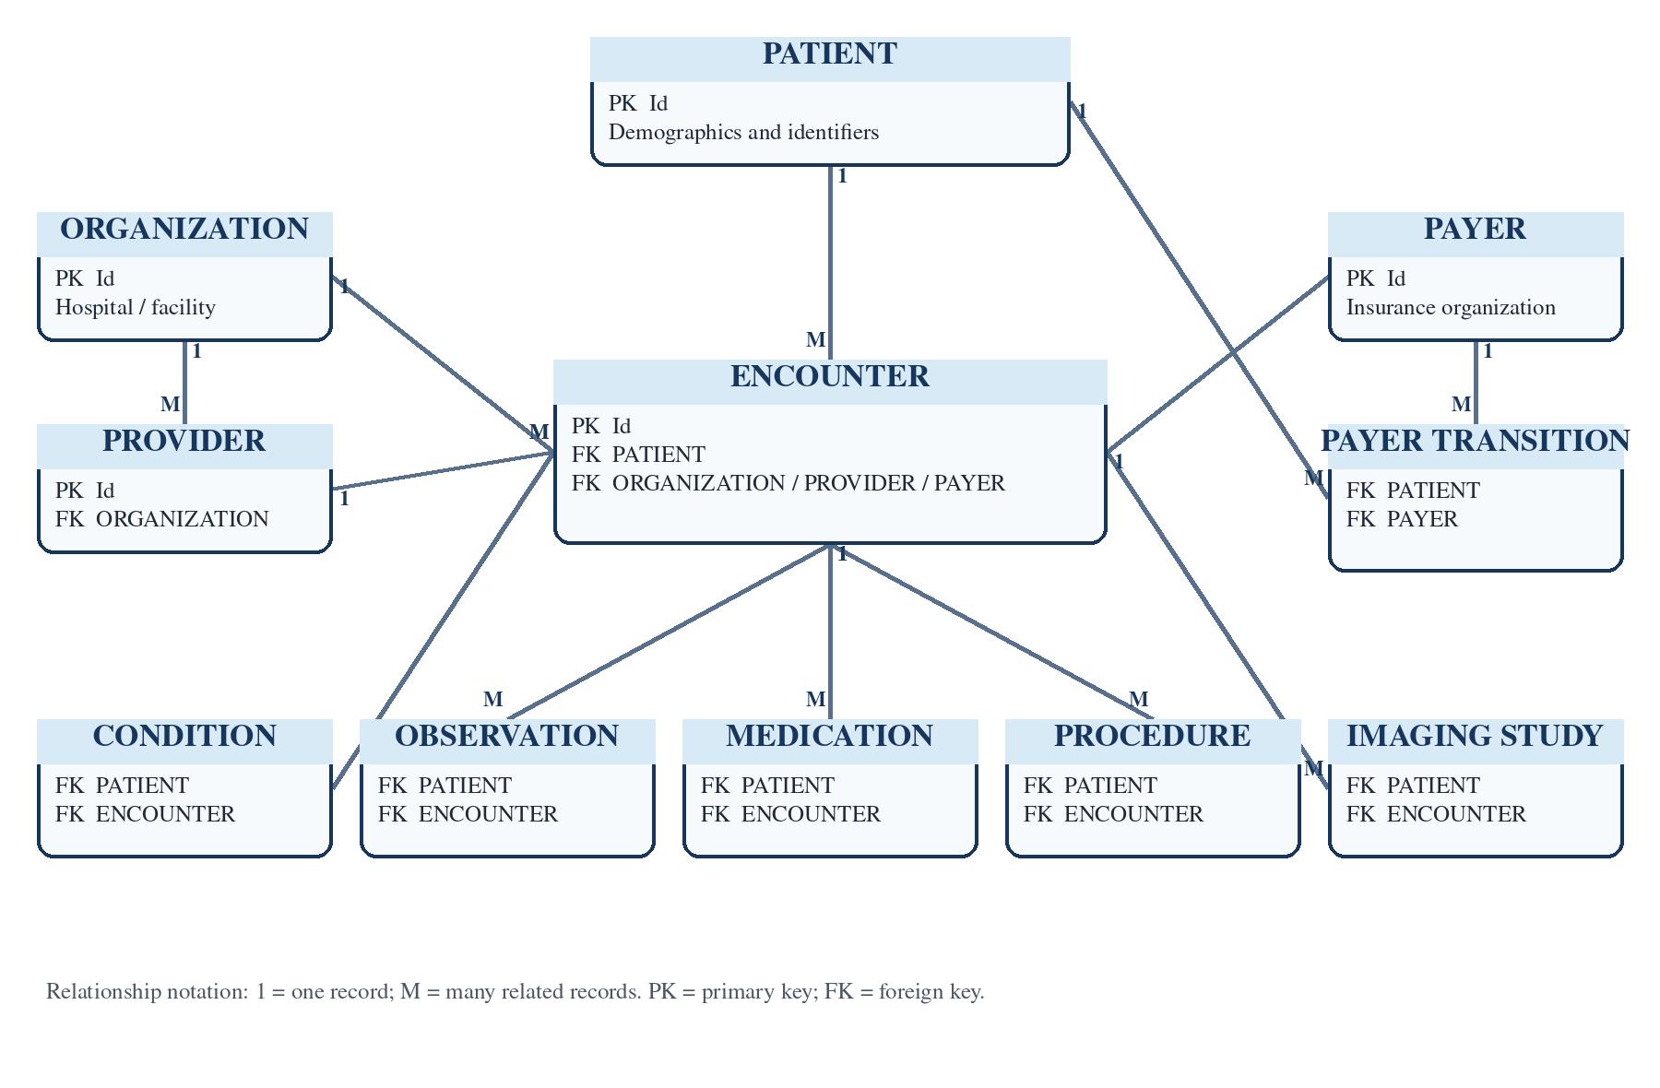
Figure 1. Logical healthcare entity relationships used by the EHDP.
Design rule: Foreign-key failures must be reported; records must not be silently reassigned to unrelated patients, encounters, providers or payers.

11. Data Quality and Business Rules
Rule ID | Area | Rule | Required handling
DQ-01 | Patient identifier | patients.Id must be present and unique. | Reject duplicate or missing identifiers.
DQ-02 | Patient relationship | Every patient foreign key must resolve to patients.Id. | Reject or quarantine orphan records.
DQ-03 | Encounter relationship | Encounter references must resolve to an existing encounter where required. | Reject or quarantine orphan encounter references.
DQ-04 | Date validity | Dates must be parseable and START must not occur after STOP. | Flag invalid chronology and formats.
DQ-05 | Monetary values | Costs and coverage values must be numeric and must not be negative unless explicitly allowed. | Reject or flag invalid amounts.
DQ-06 | Controlled values | Gender, encounter class and other controlled fields must use approved values. | Map approved variations or reject invalid values.
DQ-07 | Duplicate control | Natural or declared keys must be checked before loading. | Prevent unintended duplicate target records.
DQ-08 | Reconciliation | Input, output and reject counts must reconcile for each run. | Mark the run failed when counts cannot be explained.

12. Reporting and Analytics Requirements
- Patient registration and demographic summaries.
- Encounter volume by class, time period, organization and provider.
- Common conditions, procedures and medication utilization.
- Laboratory and observation summaries using documented units and codes.
- Insurance coverage, payer activity, claim cost and billing-derived measures.
- Data-quality scorecards showing valid, rejected, duplicate and orphan records.
- ETL operational reporting showing run status, duration, row counts and errors.
Reporting control: Every KPI must have a documented definition, source fields, transformation logic and grain before it is published in Power BI.

13. Non-Functional Requirements
ID | Category | Requirement
NFR-01 | Performance | Pipelines must process approved controlled batches without unresolved failure.
NFR-02 | Scalability | The design must support additional hospitals, datasets and records without redesigning the entire platform.
NFR-03 | Maintainability | Configuration, reusable transformations and clear repository separation must be used.
NFR-04 | Auditability | Every run and material transformation must be traceable.
NFR-05 | Security | Access must be limited to authorized users and sensitive fields must be identified.
NFR-06 | Recoverability | Failed jobs must be restartable without corrupting or duplicating accepted data.
NFR-07 | Portability | Environment-specific settings must be externalized and documented.
NFR-08 | Usability | Trusted datasets and field definitions must be understandable to report developers and reviewers.

14. Assumptions, Dependencies and Constraints

14.1 Assumptions
- Synthea data is synthetic and does not represent real patient identities.
- Approved source schemas remain sufficiently stable during the project.
- The team has access to the required development tools and environments.
- Business definitions will be reviewed before Gold-layer reporting is approved.

14.2 Dependencies
- Availability and installation of Pentaho Data Integration and PostgreSQL.
- Agreed source-to-target mappings and data-quality rules.
- Repository access and team adherence to Git workflows.
- Stakeholder review of requirements, acceptance criteria and reporting definitions.

14.3 Constraints
- The project duration is three months and is delivered through Agile sprints.
- Pentaho, PostgreSQL, Python/Pandas, Power BI and Git are mandated technologies.
- Appointment, real-time ICU and full radiology content require additional sources.
- Production-grade deployment is outside the initial academic implementation scope.

15. Risks and Mitigation
ID | Risk | Impact | Mitigation | Level
R-01 | Different source formats increase ETL complexity. | Incorrect or delayed ingestion | Use the correct Pentaho input steps and test each format independently. | Medium
R-02 | Missing or inconsistent data reduces trust. | Incorrect reporting | Validate, quarantine and document data-quality failures. | High
R-03 | Incorrect source-to-target mappings corrupt target meaning. | Wrong PostgreSQL values | Review mappings and link them to test cases. | High
R-04 | Large datasets may reduce pipeline performance. | Slow or failed loads | Use controlled batches, monitoring and performance testing. | Medium
R-05 | Different team configurations cause execution differences. | Deployment and collaboration issues | Externalize configuration and document environment setup in Git. | Medium
R-06 | Scope gaps are mistaken for available data. | Unsupported reporting claims | Maintain an explicit data-gap register and approve any additional dataset. | High

16. Acceptance Criteria and Definition of Done
- Approved business requirements are addressed and traceable to implementation evidence.
- Pentaho ETL pipelines execute successfully for the agreed test inputs.
- PostgreSQL staging tables are populated with reconciled record counts.
- Data-quality checks and rejected-record handling are documented.
- Source-to-target mappings, metadata and lineage information are current.
- Pipeline reruns do not create unexplained duplicate records.
- Code, ETL files, SQL, tests and documents are committed with meaningful Git history.
- The sprint review presentation and technical documentation are complete.

17. Requirements Traceability Matrix
Requirement | Source | Process / component | Target / evidence | Test case
BR-01 | Approved Synthea files | Pentao ingestion jobs | Bronze/staging tables | TC-01 Source ingestion
BR-02 | patients.csv | Patient validation | stg_patients | TC-02 Patient key
BR-03 | encounters and related files | Relationship validation | stg_encounters + clinical staging | TC-03 Referential integrity
BR-04 / BR-05 | All selected sources | Validation and reject handling | Valid and reject tables/logs | TC-04 Data quality
BR-06 / BR-07 | Validated source data | Bronze-to-Silver transformations | PostgreSQL Bronze/Silver | TC-05 Transformation
BR-08 | Curated Silver data | Gold preparation | Analytics-ready tables | TC-06 Reporting dataset
BR-09 / BR-10 | ETL runtime and mappings | Audit/metadata process | Audit, metadata and lineage records | TC-07 Traceability
BR-11 | Controlled repeat input | Idempotent load logic | Target tables | TC-08 Rerun control
BR-12 | Project artifacts | Git workflow | Repository | TC-09 Version control

18. Repository and Documentation Requirements
The repository shall separate documentation, configuration, datasets, Bronze ingestion, Silver cleansing and validation, Gold warehouse and analytics, Pentaho transformations and jobs, Python, SQL, metadata, lineage, dashboards, deployment and tests.
Sprint 0 closure condition: The backlog item for repository structure should be marked Done only after the agreed folders exist in Git and are verified—not merely because a draft structure document exists.

19. References
- UC2_Project_Charter.pdf - project background, objectives, scope, stakeholders, architecture, sprint plan and success criteria.
- Project_Structure.pdf - Bronze-Silver-Gold repository structure and Definition of Done.
- Sprint 0 Backlog - EHDP.csv - Sprint 0 activities and completion status.
- data_dictionary.csv - supplied appointment/encounter-oriented data fields and descriptions.
- IMG-20260820-WA0011.jpg - supplied high-level solution architecture concept.
- IMG-20260819-WA0005.jpg - supplied Synthea use-case mapping and identified gaps.

20. Final Sign-Off
Signing this document confirms that the stated requirements, scope, assumptions, gaps and acceptance criteria form the agreed business baseline for the EHDP implementation.
Role | Name | Decision | Signature | Date
Data Engineering Lead |  | Approve / Reject
Project Guide |  | Approve / Reject
Business Representative |  | Approve / Reject
Project Team | Smrithi Rajan / Febi Sarju / Harish G | Acknowledged

